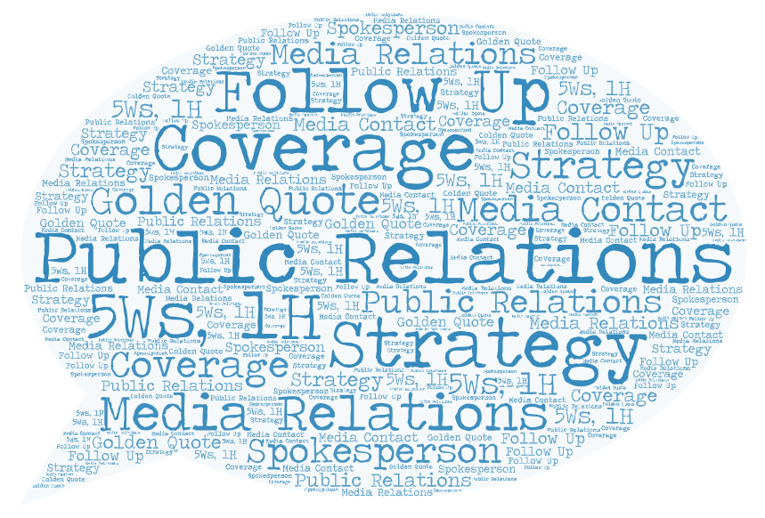

The Truth About
Press Release

The Truth About This Books, first…

This is not a book that will teach how to write a press release.
There are plenty of books for that. I’m sure you would have studied or are studying a book about it as part of your communications course in college.
This book is about learning the purpose of press release.
This book is about understanding when you should work on a press release.
This book is about knowing what results can be generated by press release.
This book is about creating your own strategy for your next press release.

What you will learn in this book:
- What is a press release – not by definition but by purpose.
- Who cares about your press release – People do when you are a known name, the announcement is big or ground breaking (EKI tying up with Shell)?
- When to issue a press release
- What alternatives are available
- Structure of press release
- How to disseminate the PR

Quotes: When a measure becomes a target, it ceases to be a good measure (Goodhart's law)

Every month I issue 15-20 press releases for my clients, which are the crème de la crème of clientele one can work with. These press releases are about funding, corporate alliances, mergers & acquisitions, appointments, product launches, awards, weddings, speeches, et al. Journalists wait for these press releases and publish the announcements the moment they receive it in their email. At the end of the month, I submit a voluminous coverage dossier to my clients. They get so happy that they settle my invoices within two days.
This is every PR professional’s dream.
However, the reality is quite different, and most cases painful.
I don’t have a crème de la crème of clients who raise funds or form alliances every month, acquire new companies or get acquired by others, launch products every few days, win Oscars/Grammy’s/Nobel, appoint new CEOs/MDs, give speeches in IIT or IIM or G20 regularly, or organise million-dollar weddings. Therefore, I don’t get to issue a press release every two days, journalists don’t wait eagerly for the announcement and hence I don’t generate tons of coverage for my clients.
I know the reality very well and therefore what I do, instead of the above, is look for the right opportunity to engage with journalists even if that means generating only a handful of coverage. At least, I generate relevant and quality coverage that make my clients visible to their target audience with the messaging that is aligned with their corporate objectives. For doing all this, I take my payment in advance.
I know doing PR in this fashion is difficult when clients demand press coverage every other day, even though they don’t have commensurate information to offer. This pressure makes PR professionals go to media with incremental information and seek coverage. Needless to say, most of them receive media’s contempt. Without coverage, the agency-client relationship goes for a toss within a few months.
There are many nuances to preventing this from happening and I hope to write a bigger document to talk about each of those soon.
In the document you are reading right now I intend to talk about what a game changer press release can be. The only requirement is to use them judiciously.

What is a press release – not just by definition
Just for records, I performed a google search *Press Release Definition* and I found 3,20,00,00,000. These are more than 3 billion results.
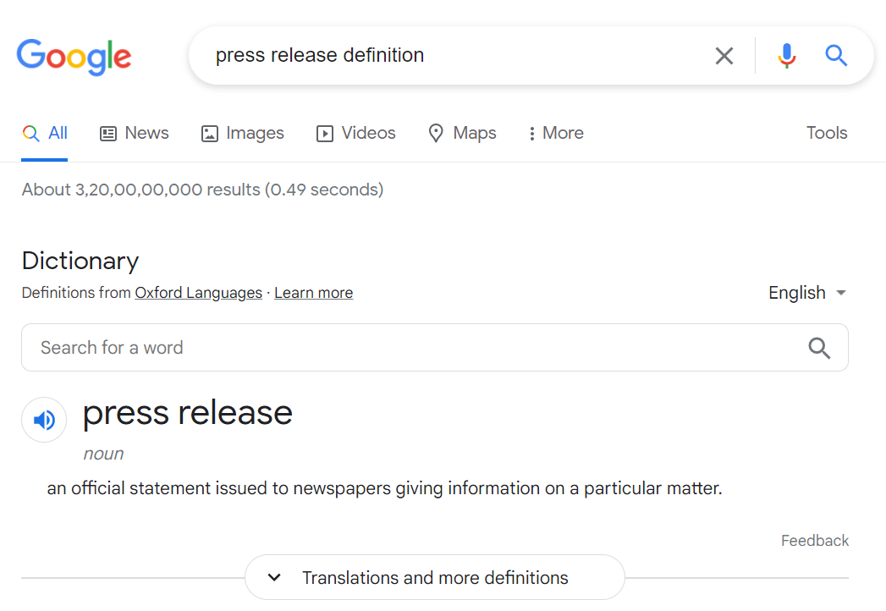

Some of the these definitions are:
“an official statement issued to newspapers giving information on a particular matter” – Dictionary.com
“a public statement given to the press to publish if they wish” – Cambridge Dictionary
“an official statement that gives information to newspapers, magazines, television news programs, and radio stations” – Merriam-Webster Dictionary
“a press release is a piece of news or information that companies send out to inform the public about something noteworthy or of material significance.” – Investopedia
Most of these definitions only infer that press release is a statement that is shared with the press for coverage. However, Investopedia stands out as it hits the nail on the head by talking about the essence of issuing a press release – “to inform the public about something noteworthy or of material significance”
If the information is not significant for the public, they won’t bother reading it. The same goes for media, who is the gatekeeper of information. Journalists will pass on the information in the form of stories only if they are convinced it will be useful for their readers. They have a brand of their own to keep, after all.
This makes it imperative for PR professionals to identify relevant information keeping in mind clients’ business objectives and how the piece of information will help better the lives of their target audience. In the absence of such a check, media and the public won’t care about the press release.

Who cares about your press release?
On a regular day, a conservative estimate suggest that a journalist receive 15-20 press releases. On a higher side, a journalist can work on 2-3 press release in addition to the special stories they are expected to churn out for their publications daily. The balance 12-17 press release are deleted from their inboxes.
To make the cut, your press release has to compete against so many others. It is needless to say that the quality of information you share in the press release has to be compelling to journalists.
There are a few exceptions to this. For example, if your client is already an established name in the industry and is a media darling, you won’t have to struggle so hard to get coverage even when the information is not compelling enough.
However, established names are seldom satisfied by PR coverage. “We could have done this ourselves” becomes their routine statement. They always want more of it. (I know you are nodding in affirmation and that underlines the pain you endure daily. ) Here also, results will be much better if the information is as compelling as the history of your client.
It is safe to say that offering a compelling piece of information is important even in the case of well-known brands.

Considering that a journalist People do when you are a known name, the announcement is big or ground breaking (EKI tying up with Shell)?

Need I say that I don’t issue press releases for everything that my clients have to say?
Press Release is a great tool.
What I do instead
Press release is a great tool to disseminate information to the target audience. But it is not a magic wand or panacea for information diarrhoea. You need to stop issuing press release to share every information you have. Better tools are available for the job, depending on what type of information you have and what the objective of sharing that information.
When talking of information, we look at it in isolation from our larger corporate objective and strategy. We start thinking of media as the target audience, whereas media is only a conduit to take your message to the target audience.
Club it with the fact that an active journalist receives anywhere between 30-50 press releases in a day. (That’s just a conservative number gathered from personal experience as a journalist and from friends still writing stories for a living.)
There is no way that a journalist can work on these many press releases in a day, so they do the next best thing – ignore most of them. A majority of those press release that they decide to work upon get published as a snippet or a column in the middle of advertisements.
Basically, a majority of press releases don’t receive the attention PR professionals and companies think they deserve.
Some of my PR friends would argue that press releases are the best medium to disseminate information to media, and they are not wrong. That’s what has been taught in colleges that impart education about journalism and mass communications.
The practical world, however, is different. Here, media does not care about your press releases. They value scoops, exclusive stories and interviews. And that’s where the magic lies.
Any information can be shared in multiple formats but our job is to share it in the format that the recipient values. Press release is not that is valued at all.
Does that mean press releases should not be used at all? I don’t mean to say that. It, sure, has a unique value if the development is first-of-its-kind (don’t use such adjectives in press releases if you want to avoid pissing off journalists reading press releases all day with similar meaningless adjectives. More on that later). Writing press releases also makes sense when you represent a renowned brand.

Press releases are thought of like a magic wand to get coverage. Anything happens in the company; the first idea is to issue a press release.

What is press release
How is it different from note to editor and concept note?
When you should issue a press release
People use press release when there no other options:
- People issue PR when they should be releasing a press note
- Issue press release when an exclusive story would do a better justice to news
Not all publications are made equal.
College education on PR was only the base you have to build upon. Can’t rely on it for all times to come. Practical knowledge has to be applied.
While some concepts look great in theory, they fail to generate the desired results in practice.

